# Team 24 – Sprint 1 Testing Document

Sakshi Choudhary, Giorgi Khmaladze, Nick Litman, Mihir Somani, Conley Utz

User Story #10

**Test 1: Given that the UI is correctly implemented, if the user clicks the “Select Category” field, then a dropdown menu appears to allow the user to make a selection**

Purpose: To meet the acceptance criteria that the UI is working as intended

Steps:

1. User clicks on the “Select Category” field

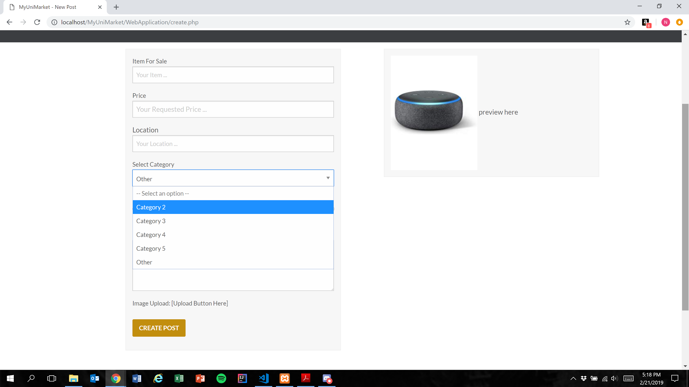

Expected Result: A dropdown menu in which the user can select one of multiple options is displayed

**NOTE:** Categories are currently placeholders as the marketplace was not implemented in Sprint 1

Test Result: **PASSED**

**Test 2: Given that the database has been implemented correctly, if the user submits a completed listing, then the database should correctly store the selected value**

Purpose: To meet the acceptance criteria that the database correctly stores the selected value for the “Select Category” field

Steps:

1. User properly inputs data in all required fields and clicks“Category 2” in the “Select Category” menu

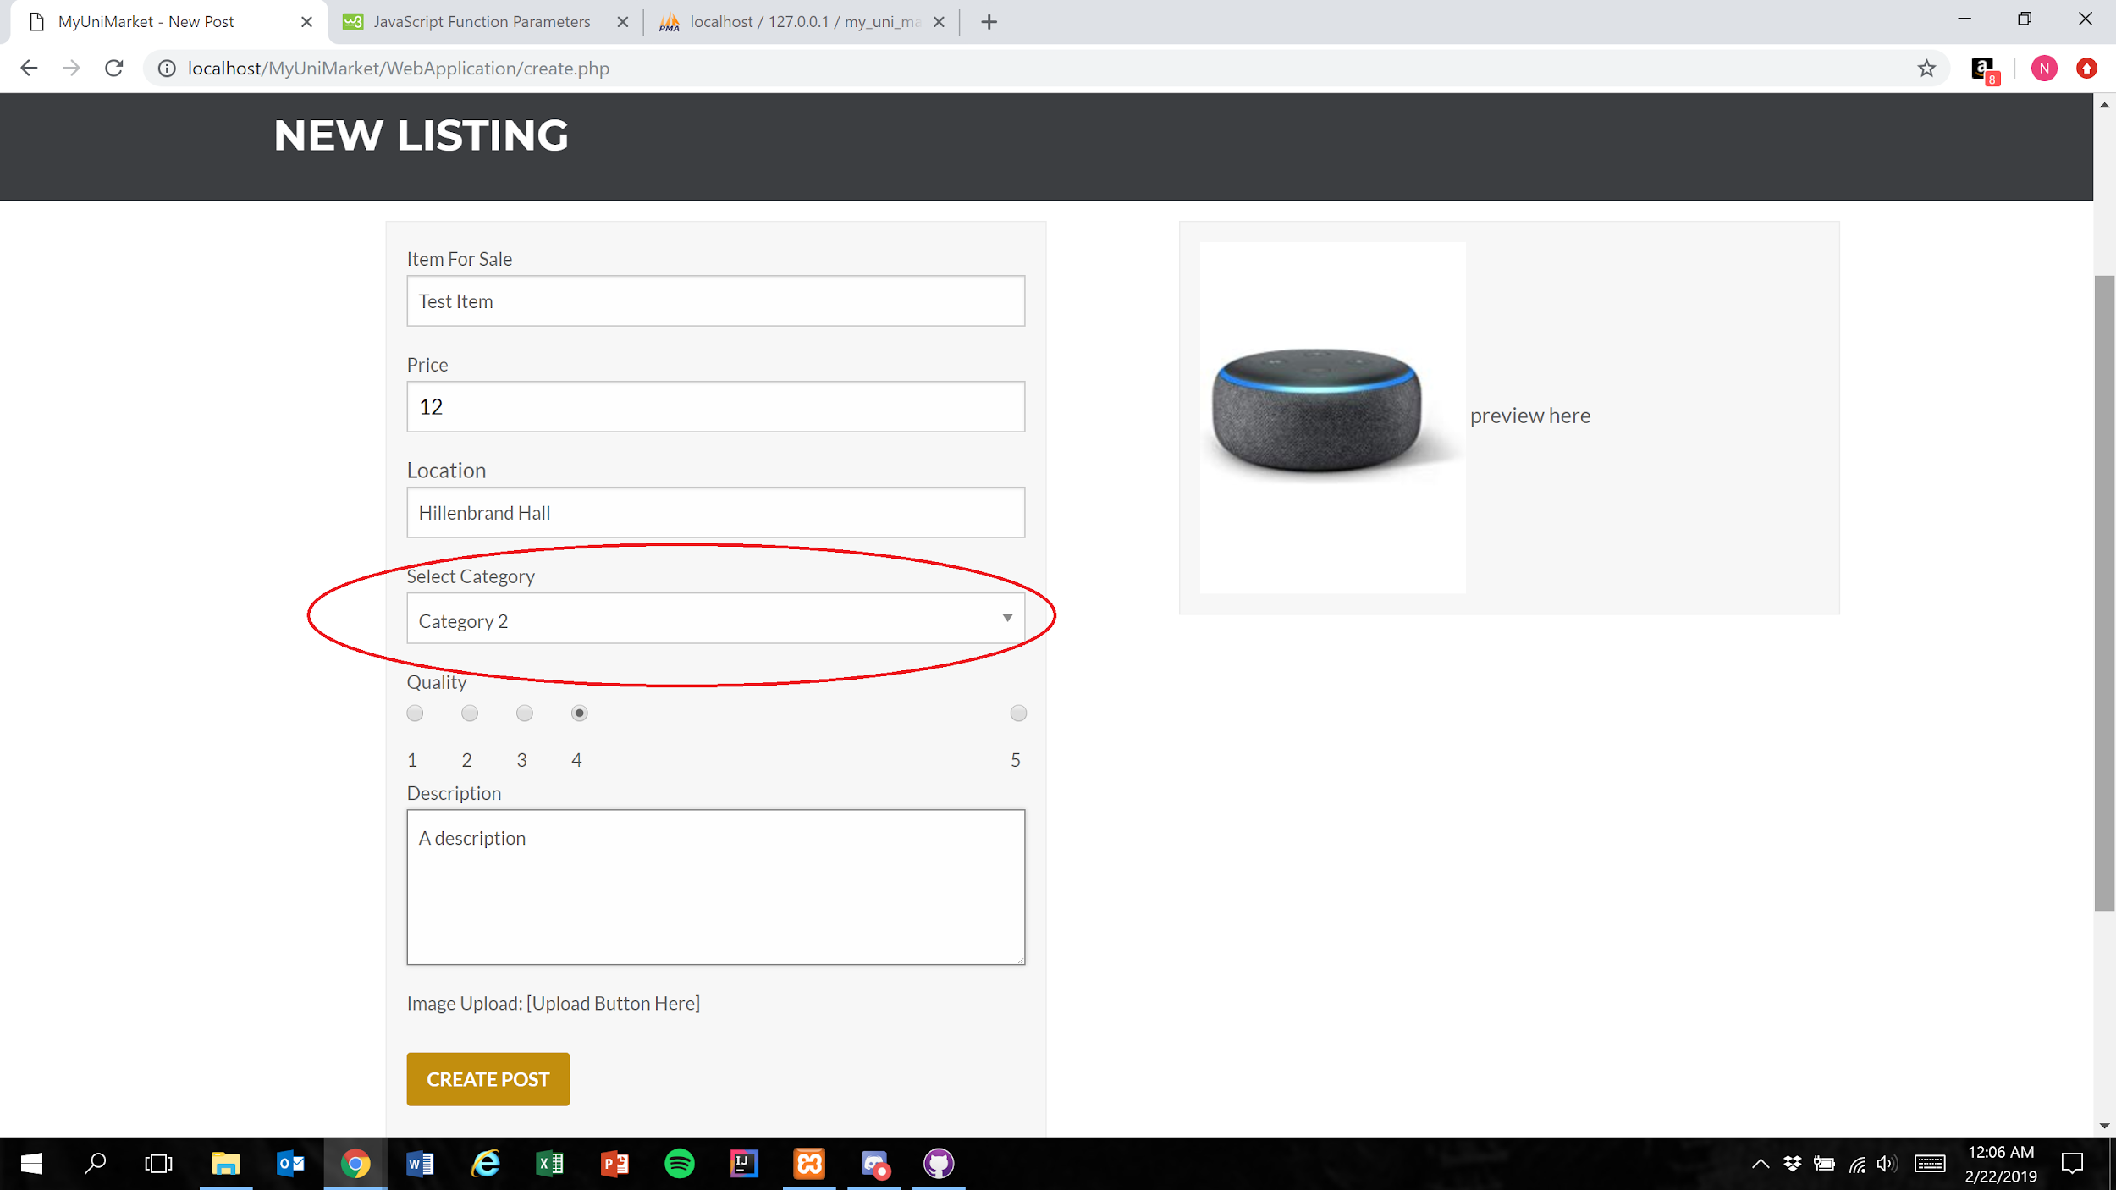

1. User presses the create post button

Figure 1

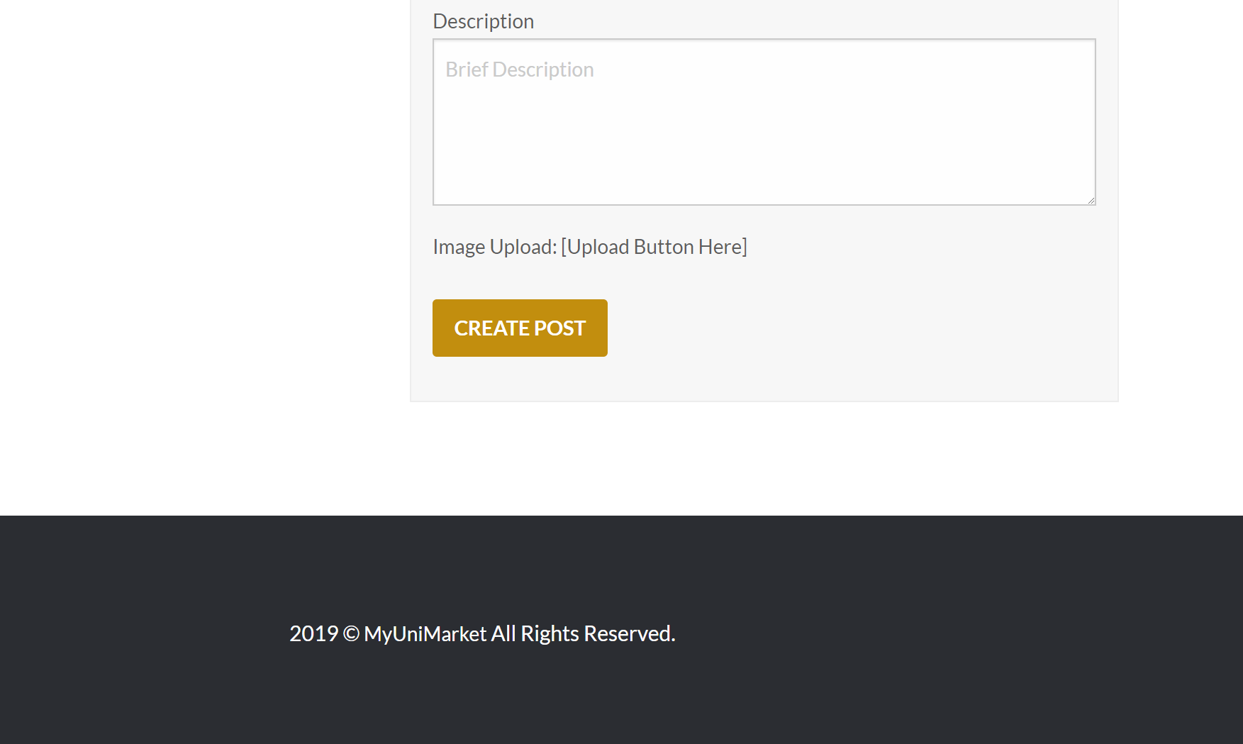

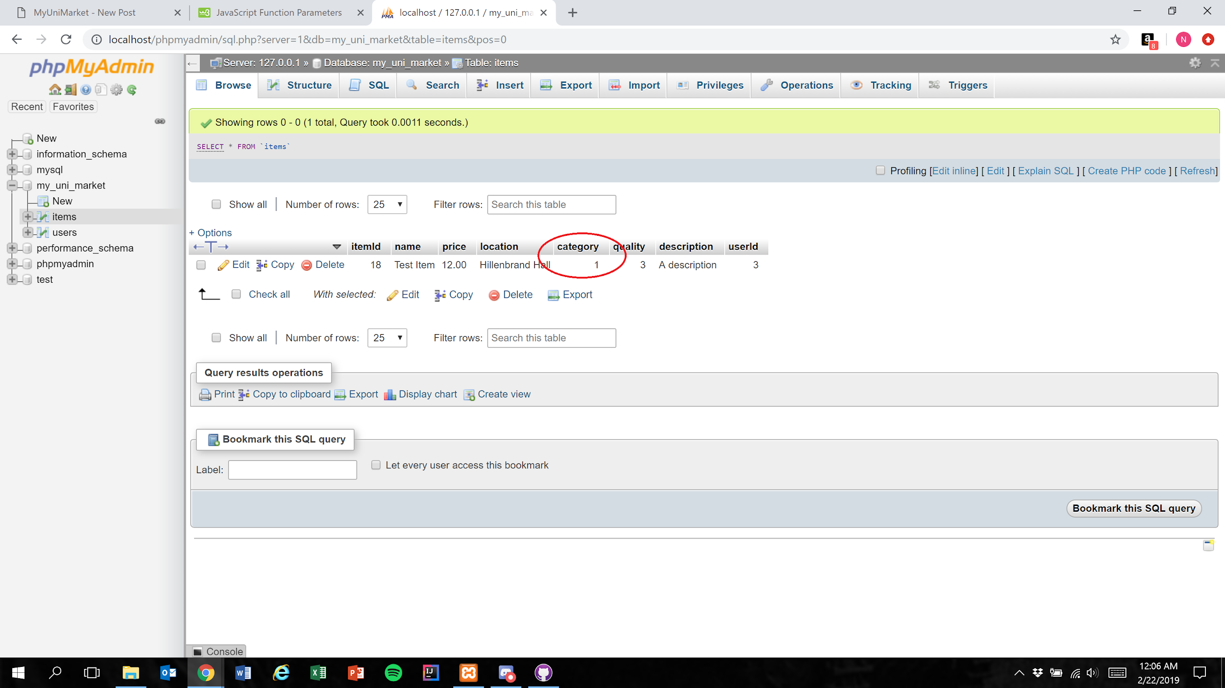

Expected Result: An integer 1 less than the category number the user selected is stored in the database

Test Result: **PASSED**

**Test 3: Given that the database has been implemented correctly, if the user submits a completed listing, then the database should correctly store the selected value**

Purpose: To meet the acceptance criteria that the database correctly stores the selected value for the “Select Category” field

Steps:

1. User properly inputs data in all required fields and clicks“Category 3” in the “Select Category” menu

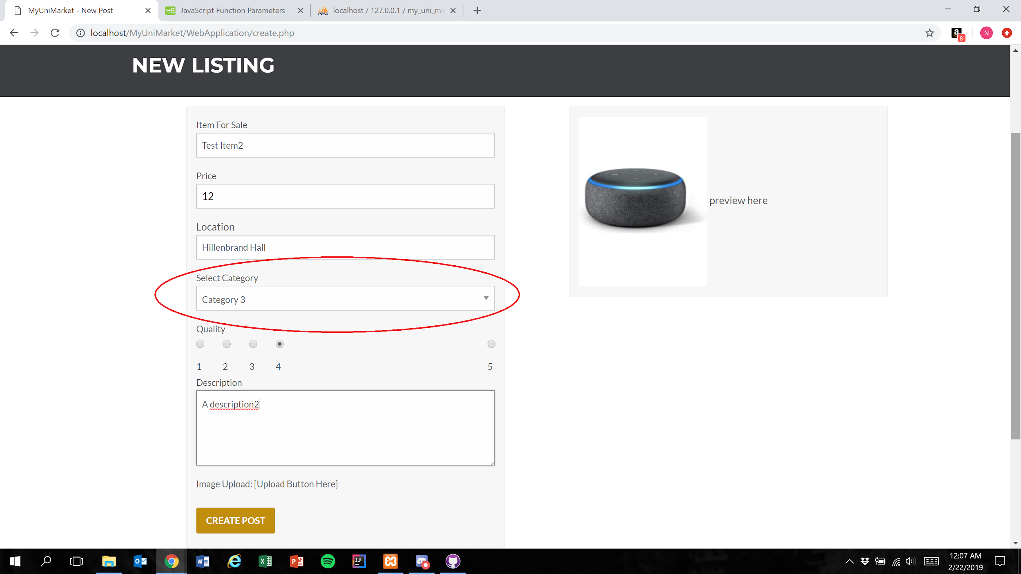

1. User presses the create post button (Figure 1)

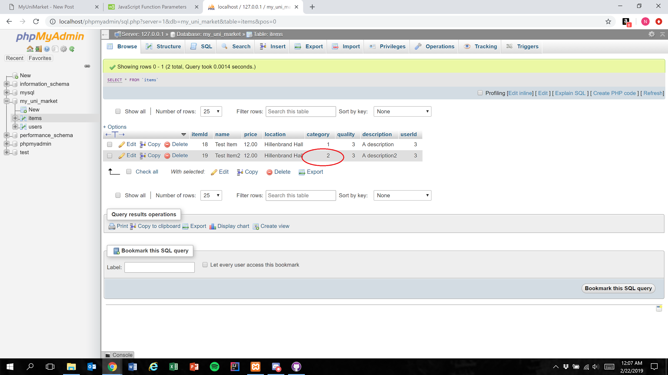

Expected Result: An integer 1 less than the category number the user selected is stored in the database

Test Result: **PASSED**

**Test 4: Given that the database has been implemented correctly, if the user submits a completed listing, then the database should correctly store the selected value**

Purpose: To meet the acceptance criteria that the database correctly stores the selected value for the “Select Category” field

Steps:

1. User properly inputs data in all required fields and clicks“Category 4” in the “Select Category” menu

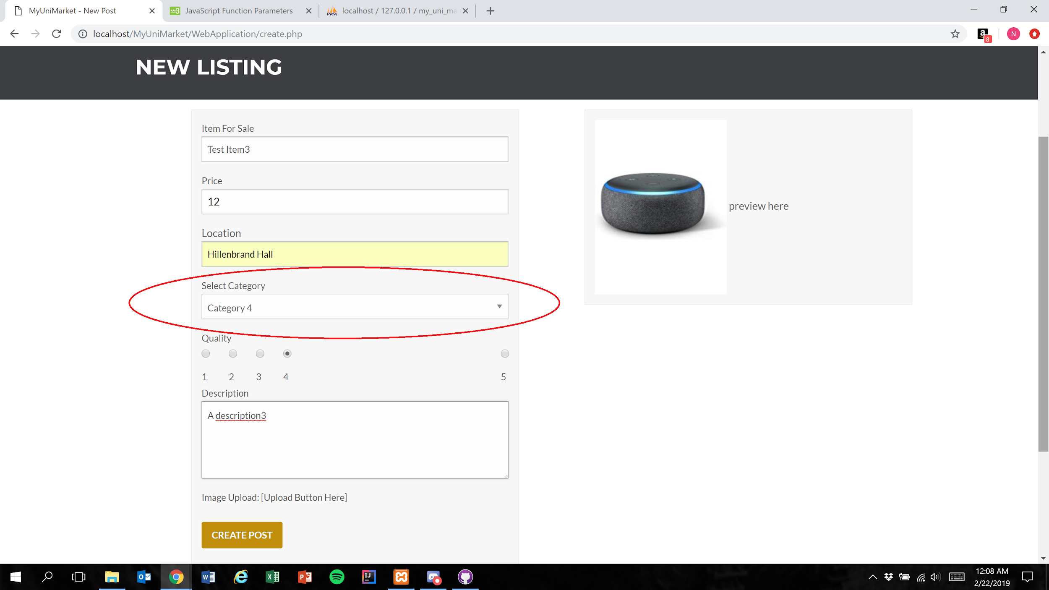

1. User presses the create post button (Figure 1)

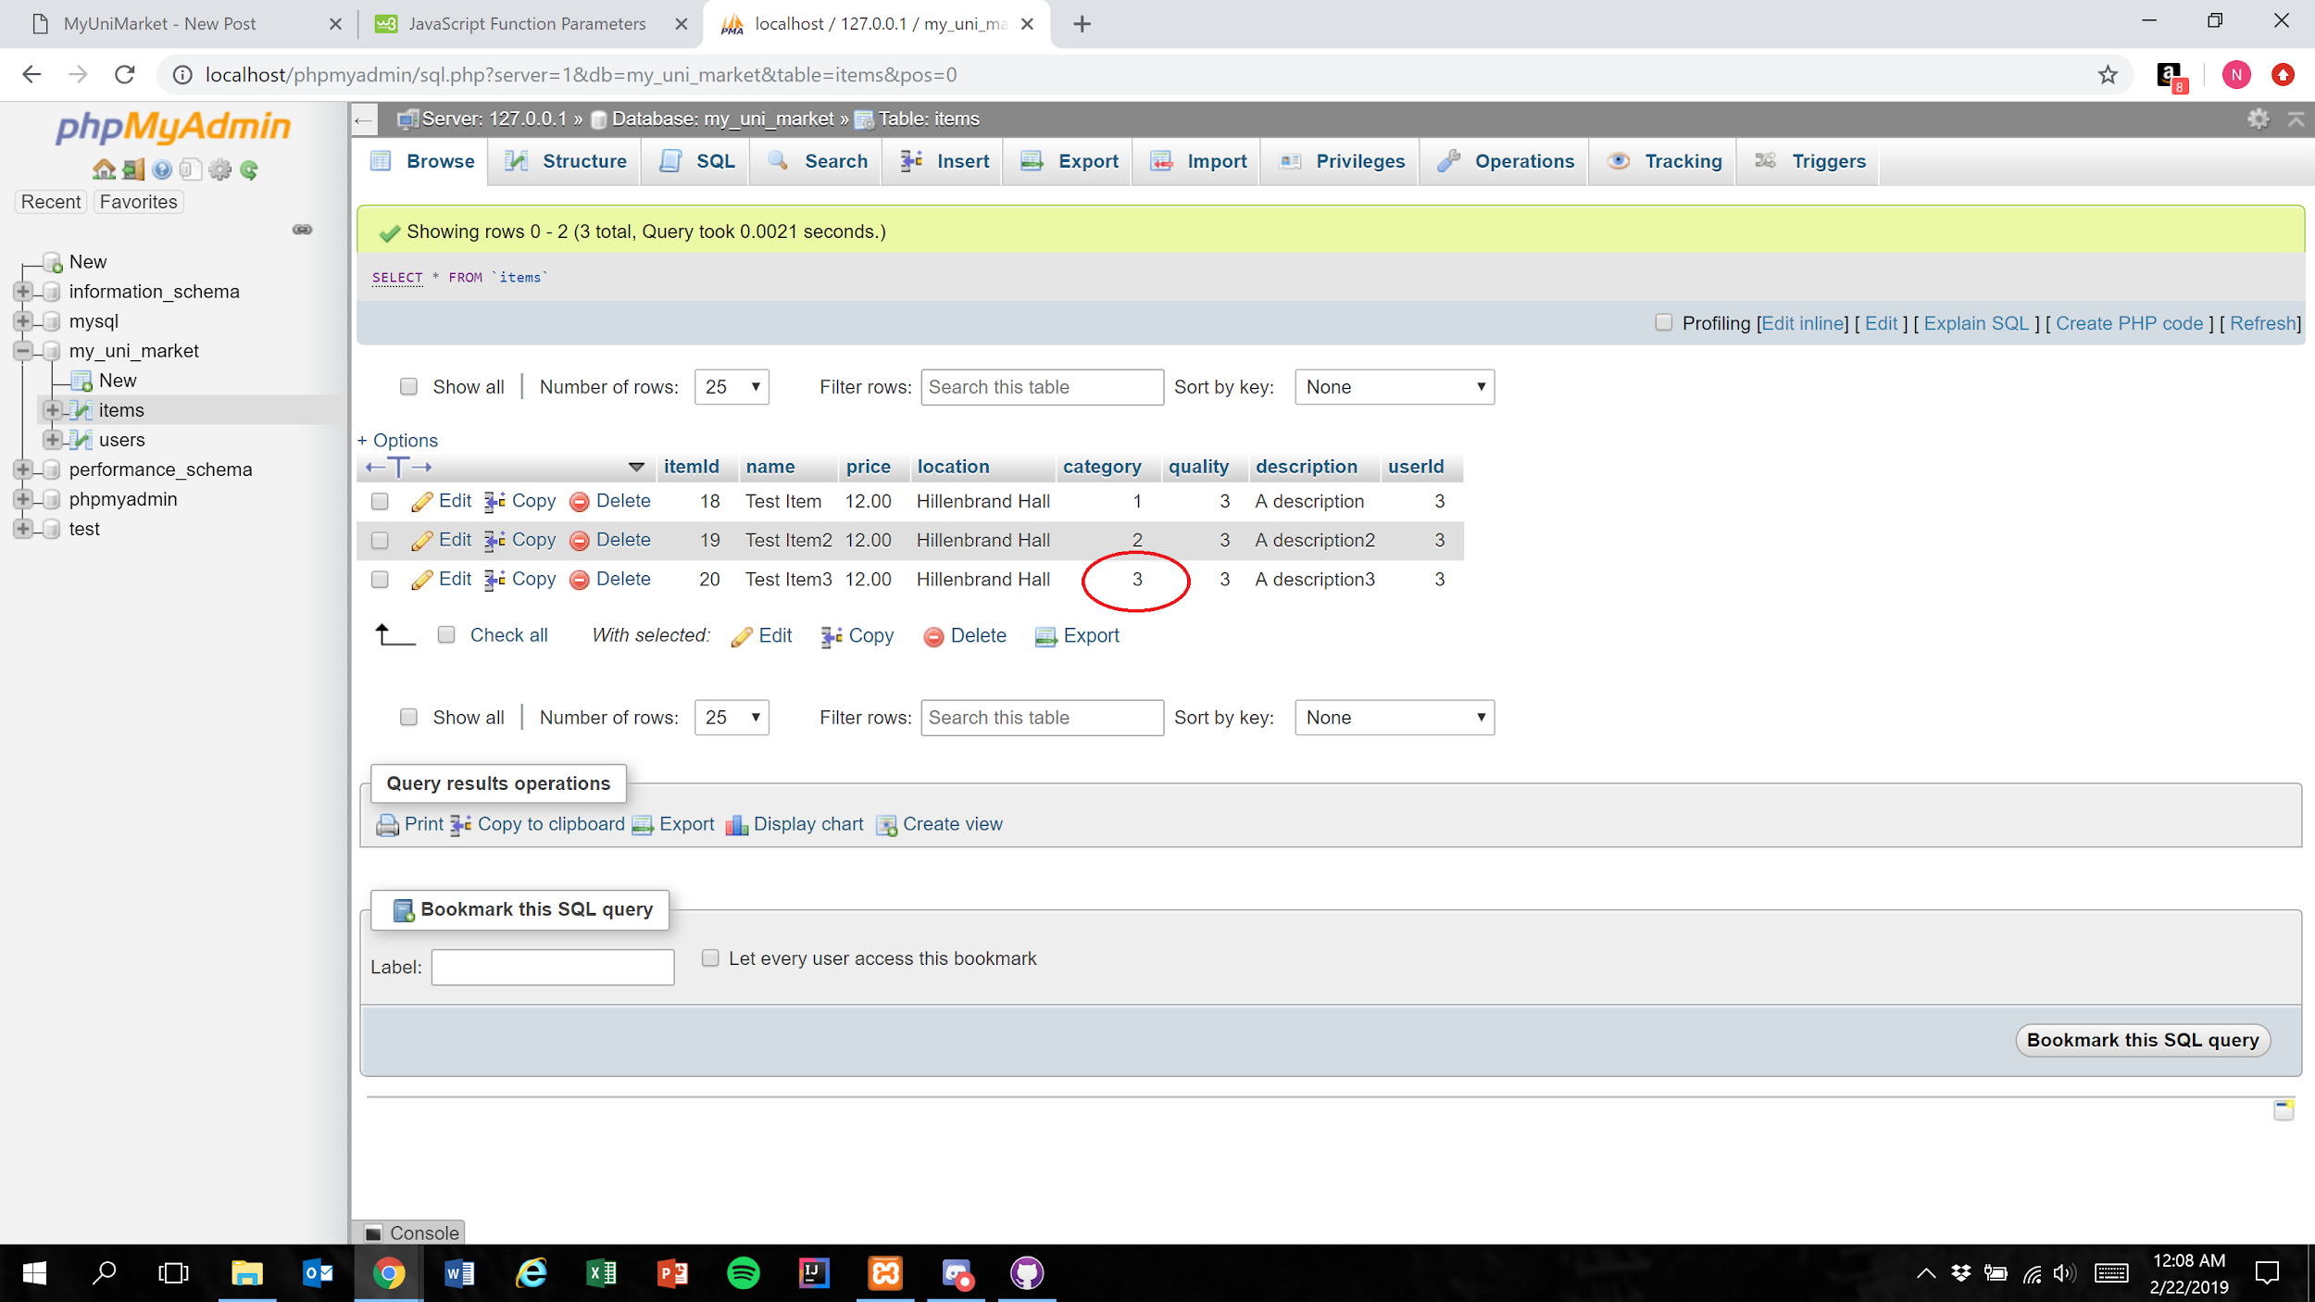

Expected Result: An integer 1 less than the category number the user selected is stored in the database

Test Result: **PASSED**

**Test 5: Given that the database has been implemented correctly, if the user submits a completed listing, then the database should correctly store the selected value**

Purpose: To meet the acceptance criteria that the database correctly stores the selected value for the “Select Category” field

Steps:

1. User properly inputs data in all required fields and clicks“Category 5” in the “Select Category” menu

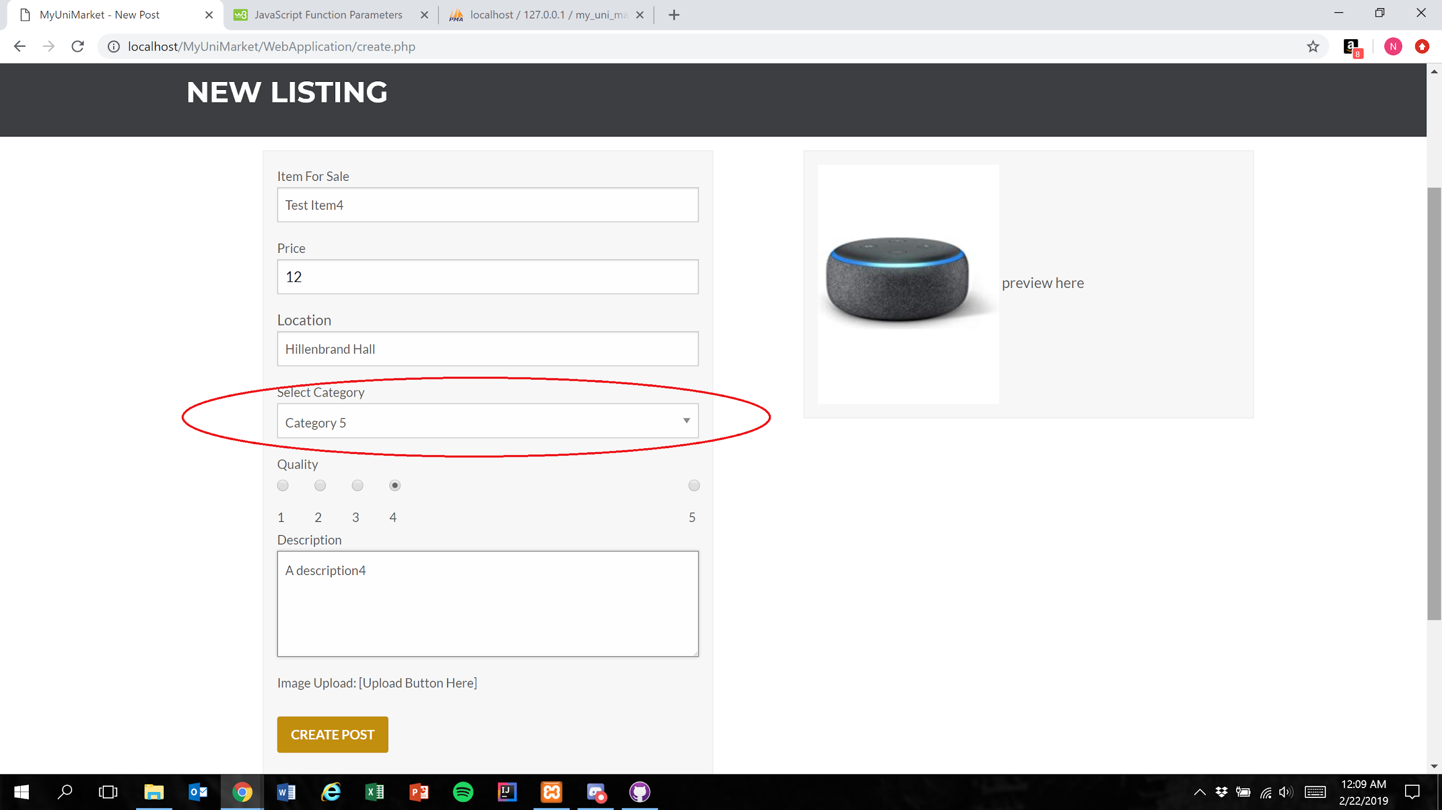

1. User presses the create post button (Figure 1)

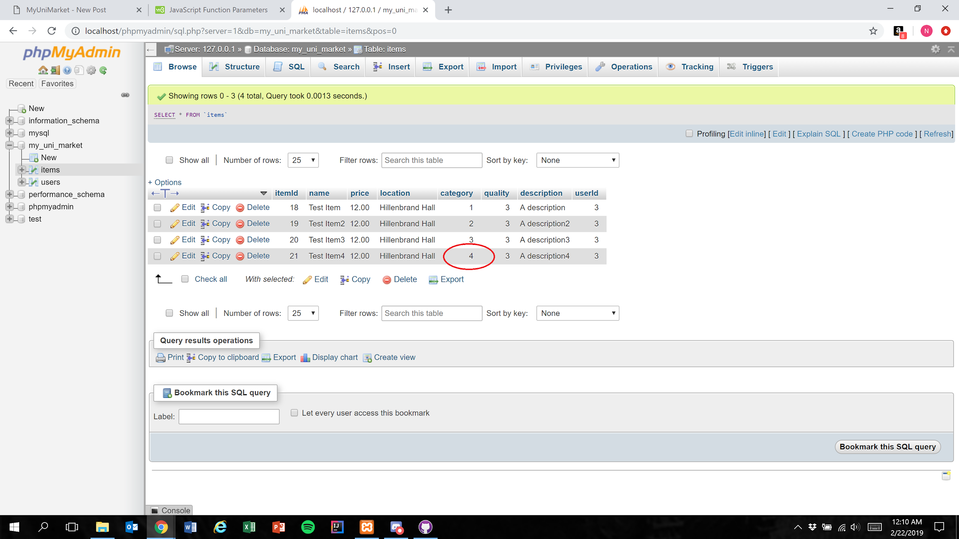

Expected Result: An integer 1 less than the category number the user selected is stored in the database

Test Result: **PASSED**

**Test 6: Given that the database has been implemented correctly, if the user submits a completed listing, then the database should correctly store the selected value**

Purpose: To meet the acceptance criteria that the database correctly stores the selected value for the “Select Category” field

Steps:

1. User properly inputs data in all required fields and clicks“Other” in the “Select Category” menu

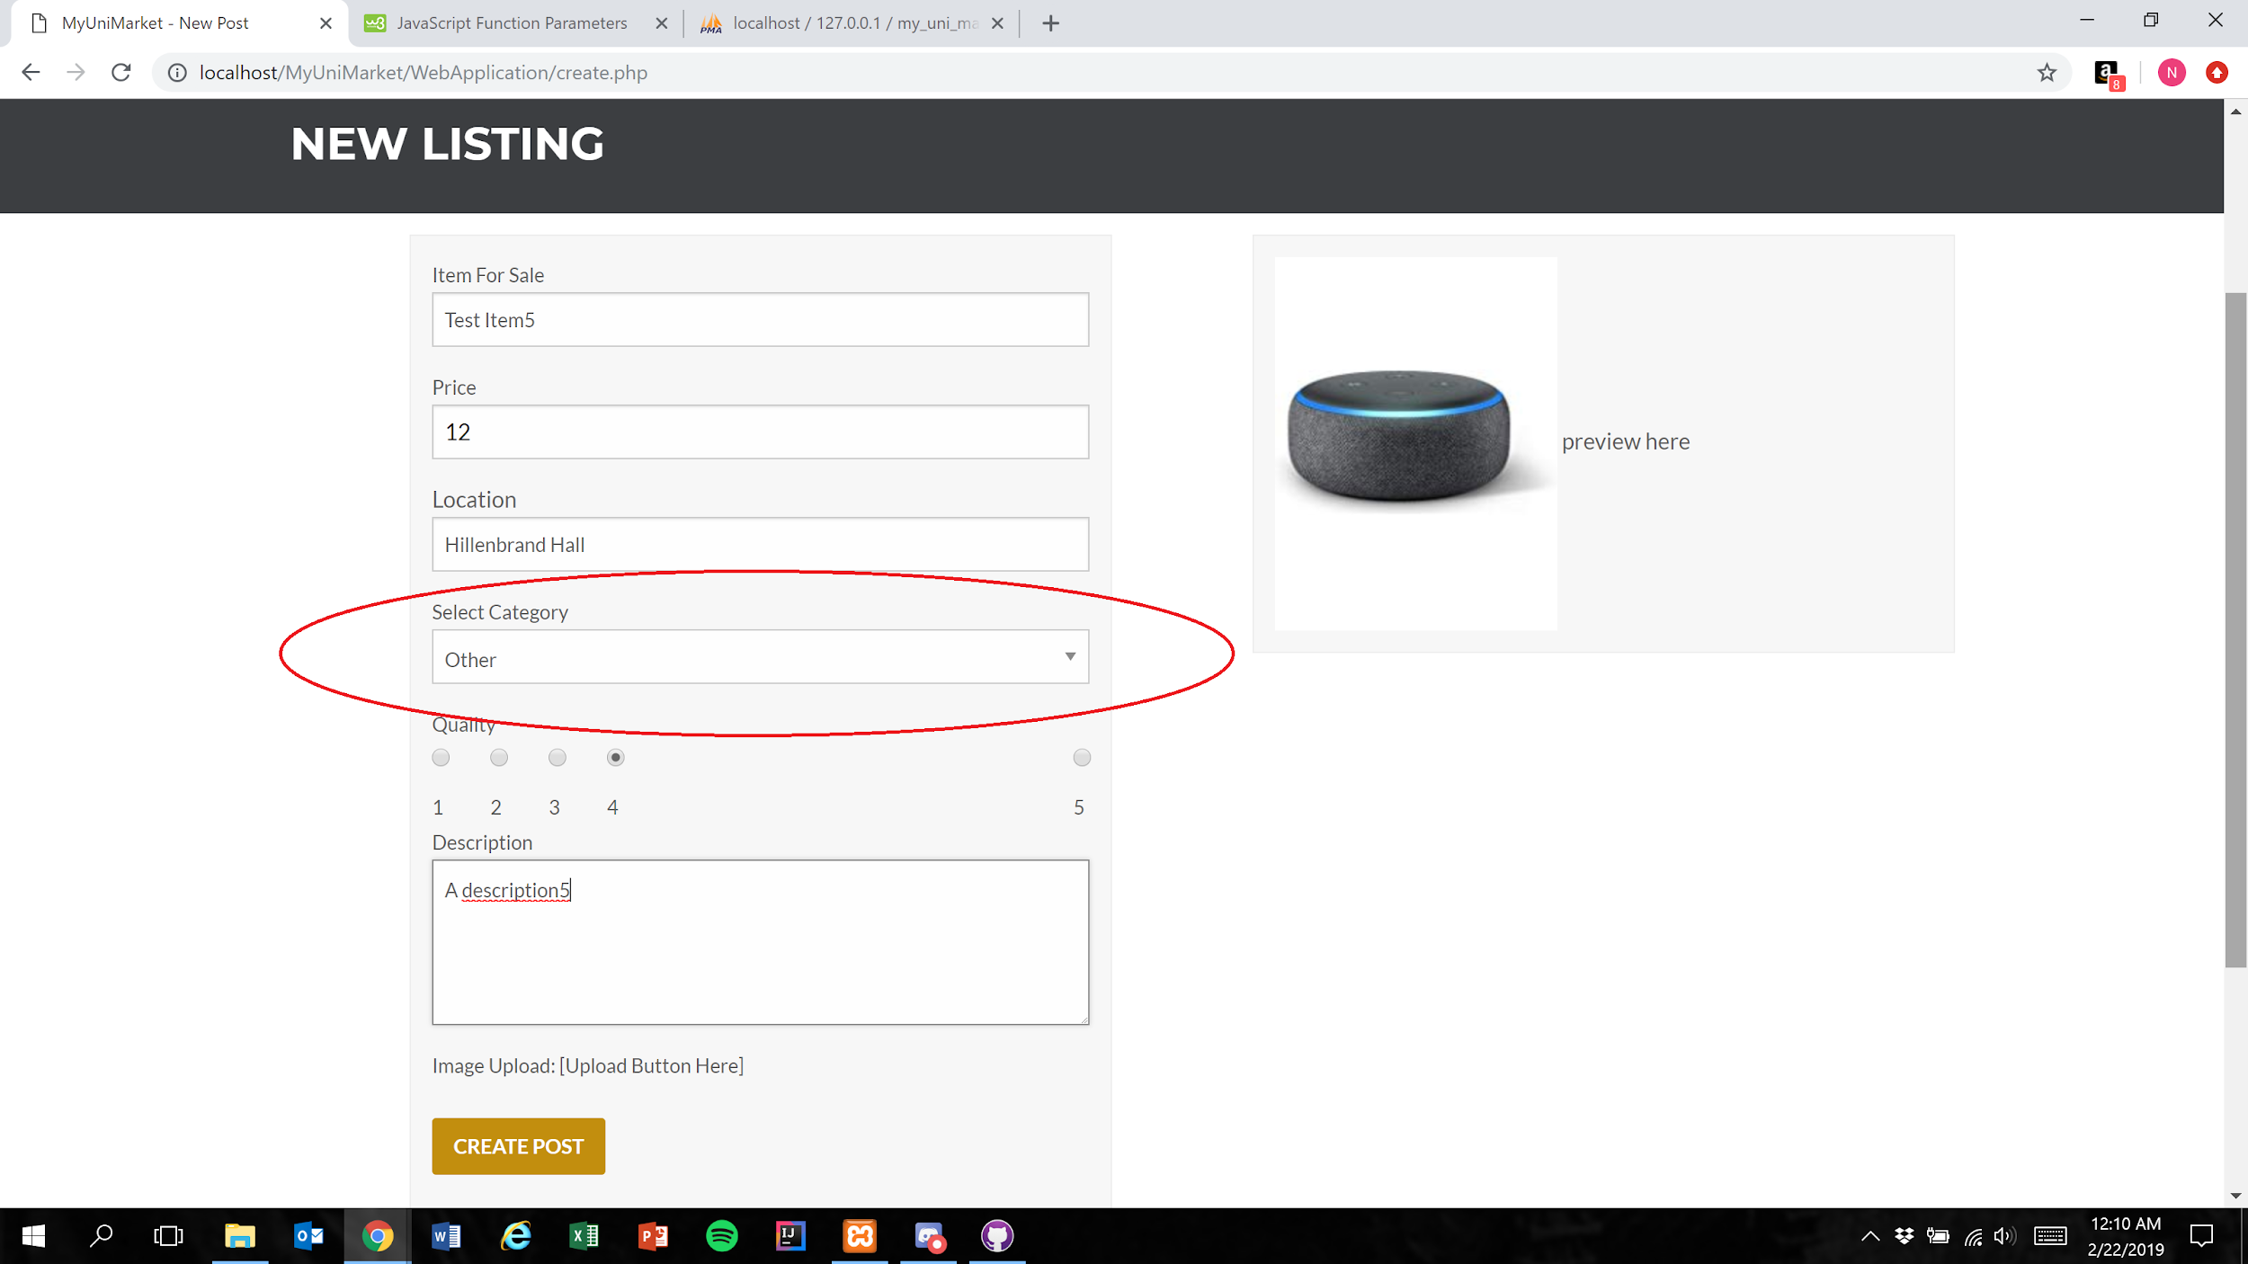

1. User presses the create post button (Figure 1)

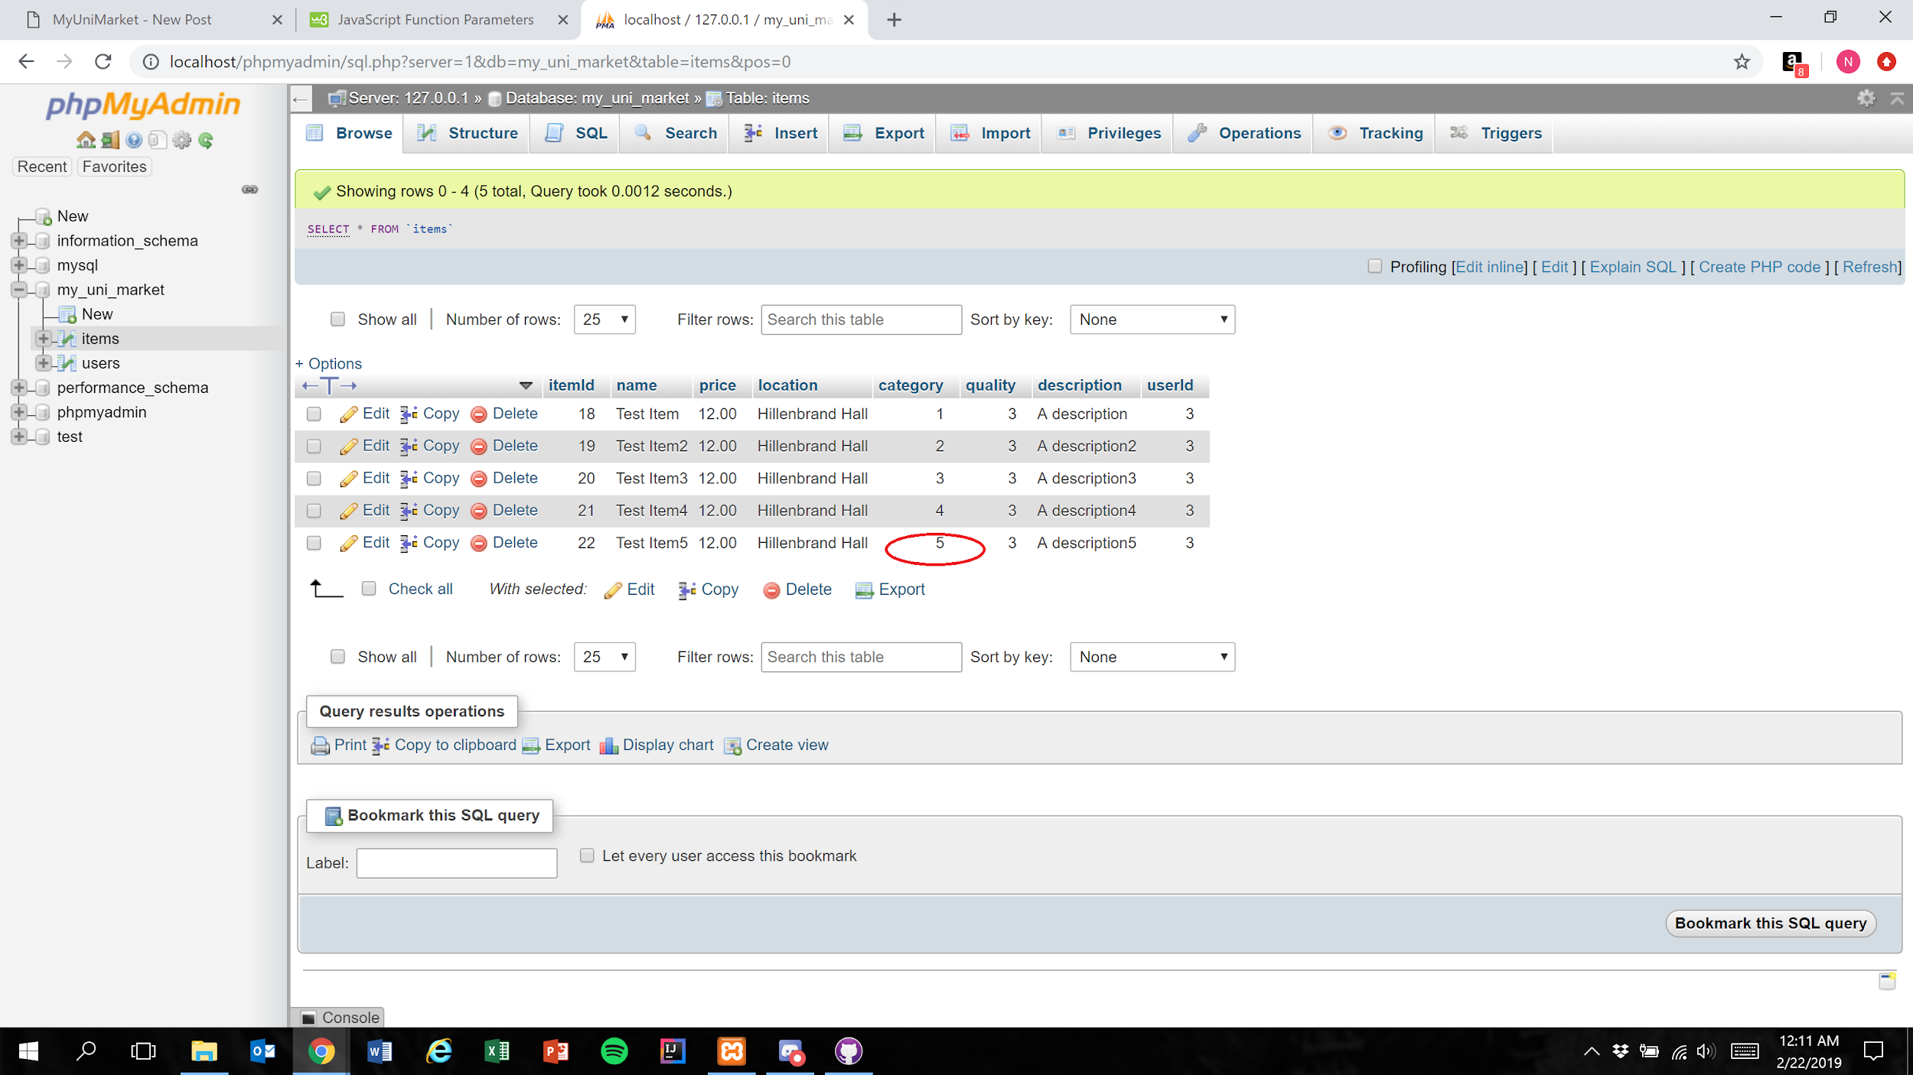

Expected Result: The integer 5 is stored in the database to represent the selection of “Other”

Test Result: **PASSED**